**Phase 2 Report: Bookme Application Redesign**

**Design Phase**

*Overview of the Redesigned Interfaces*

The updated screens aim to enhance usability and accessibility for diverse user groups, including senior citizens, disabled users, and illiterate users. The redesign is based on findings from Phase 1, focusing on resolving user-reported issues and implementing suggested solutions. HCI principles like user-centered design and accessibility drive the redesign to ensure a seamless experience for all users.

**Key Improvements**

1. Simplified Sign-Up Process

* Screen: Sign-up page.
* Enhancements:
  + Clear field labels and placeholders for input guidance.
  + Password strength requirements are explicitly mentioned.
  + While generating passwords, the strength of the password they choose is shown to facilitate users.
  + An option to auto-generate passwords according to requirements is added.
  + It also takes the date of birth as input to direct users to screens according to their age; if 60+, it directs them to a screen with larger icons along with a pop-up if they want to switch to the general screen.

*HCI Principle Applied:* **Error prevention** (clear guidance and feedback mechanisms for password strength) and personalization (directing senior users to tailored interfaces).

Before:

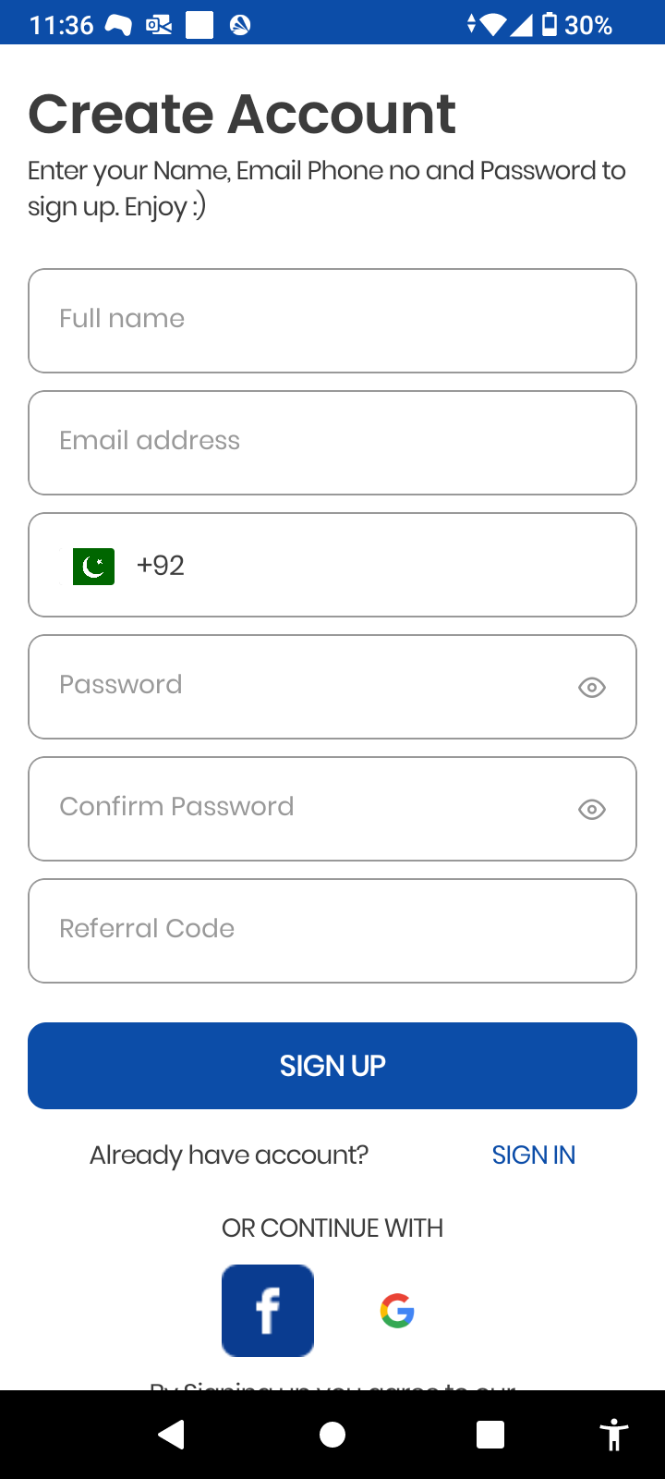

After:

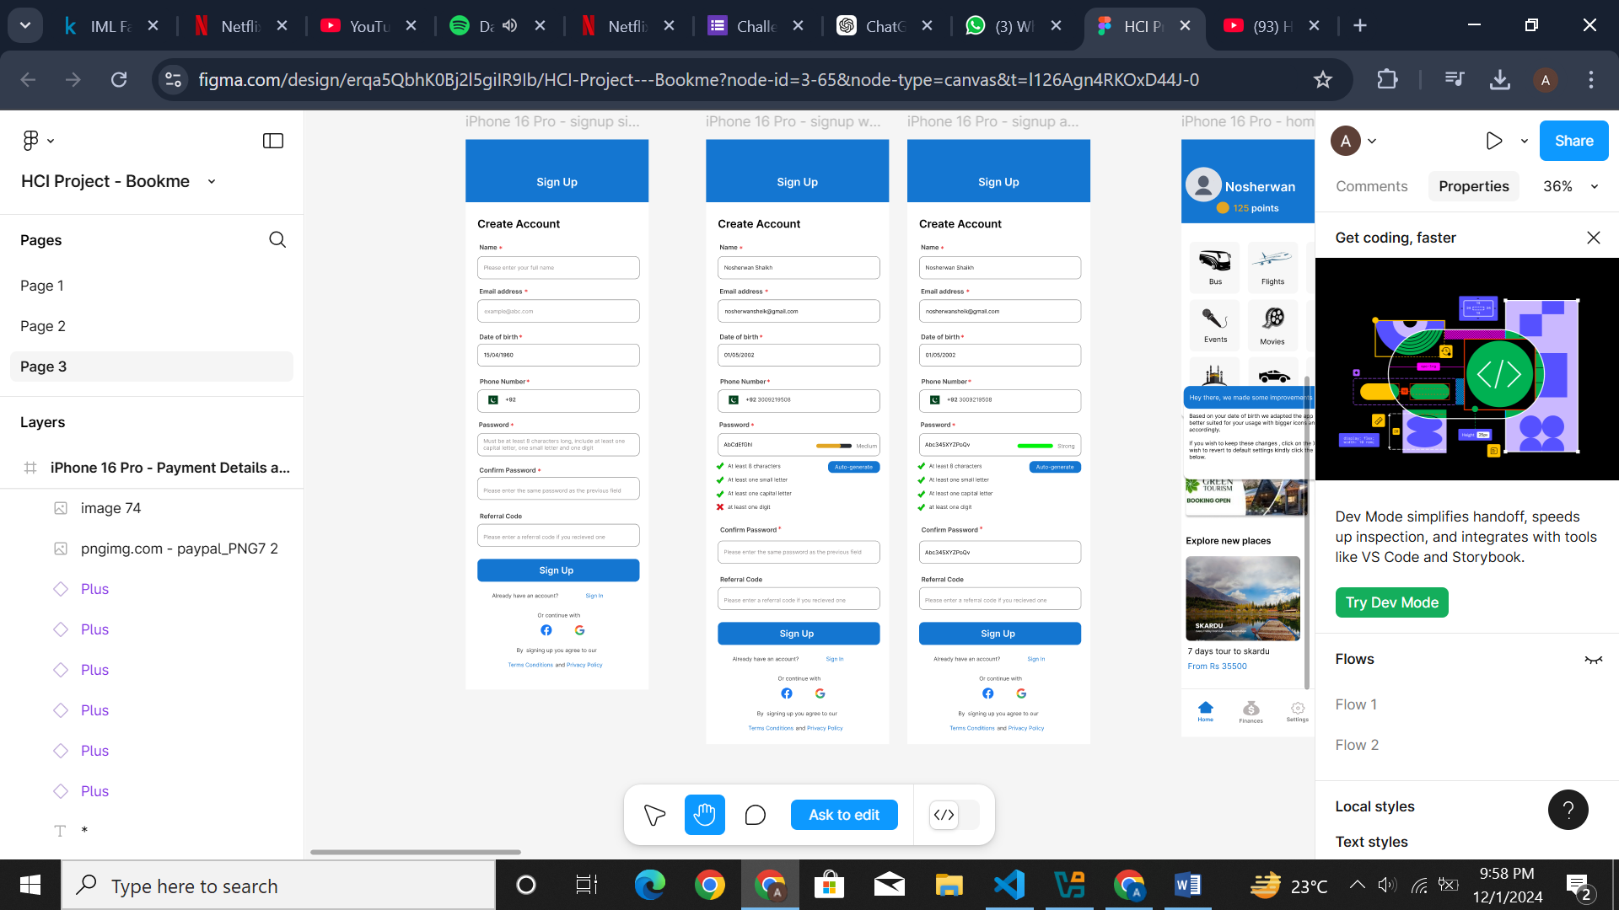

2. Personalized Screens

* Screen: Main home interface.

Whole blue boxes are made a convention to ensure **internal** **consistency** for clickable boxes.

Enhancements:

* + Quick access to all primary services (e.g., bus, flights, events, etc.) with metaphors used clearly mapping to the real world.
  + Dynamic banners showcasing offers and travel options tailored to user preferences.
  + Introduction of a tutorial pop-up for new users.
  + Options related to finances are moved to the bottom of the home screen to remove clutter and ensure easy access in one place.
  + The notification bell is moved to the top right corner of the home screen to follow convention.
  + The settings option is introduced at the bottom of the screen for easy access.
  + Labels are added to all the options at the bottom of the screen.

*HCI Principle Applied:* **Consistency** and standards (blue boxes and notification placement), **recognition rather than recall** (tutorial pop-ups for new users).

* Screen: Settings.
  + Enhancements:
    - An option to switch languages is added for users to change according to their preference.
    - An option to access accessibility features is added.
* Screen: More Options
  + Enhancements:
    - A dedicated section for users to submit feedback.
    - Separated from general settings, which was previously merged into one section.

*HCI Principle Applied:* **Flexibility** and efficiency of use (language switching and accessibility settings) and **user control and freedom** (feedback and separation of options).

Before (Home screen):

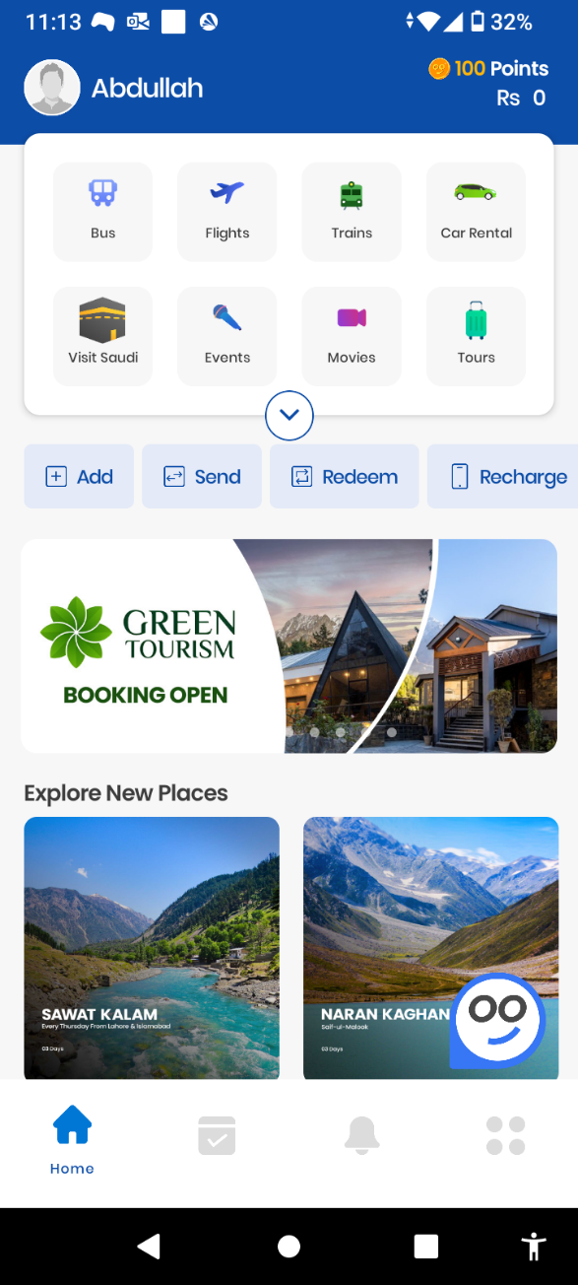

After (Home screen):

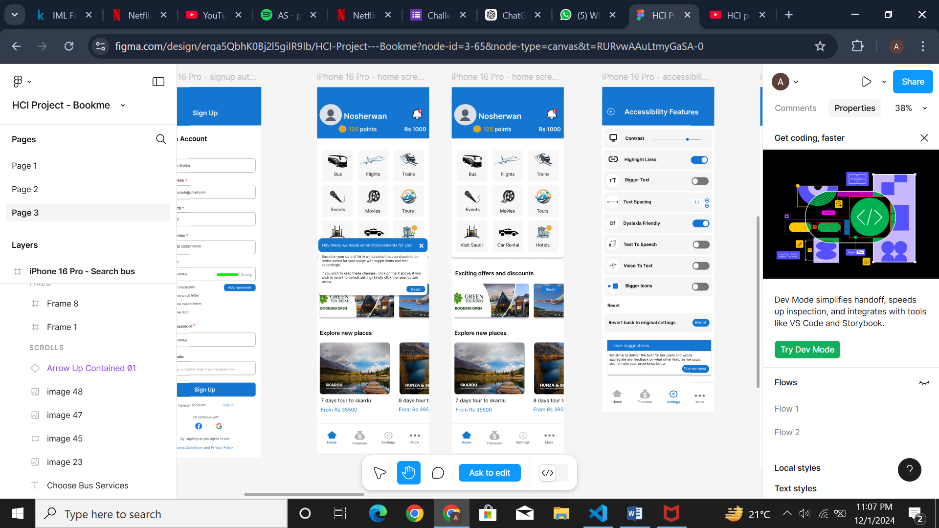

Before (Settings):

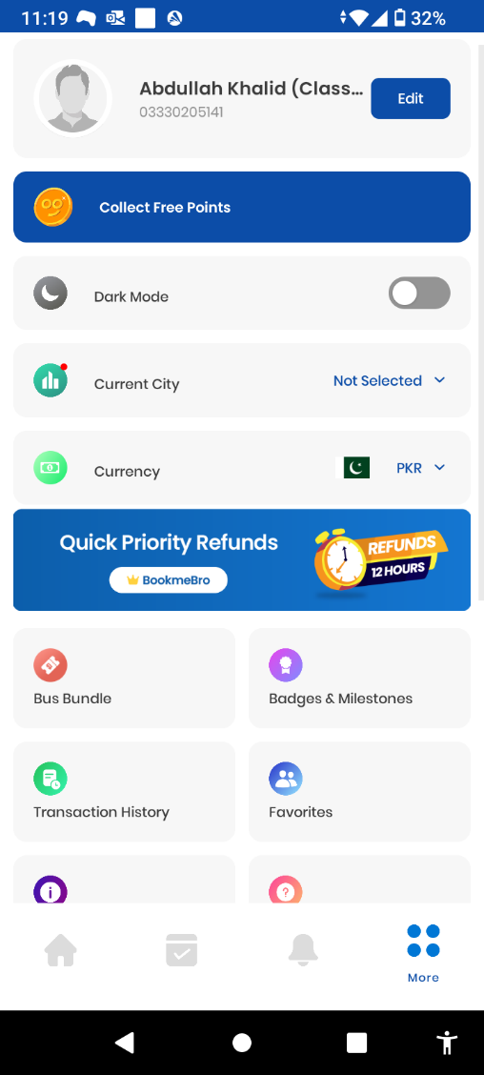

After (Settings):

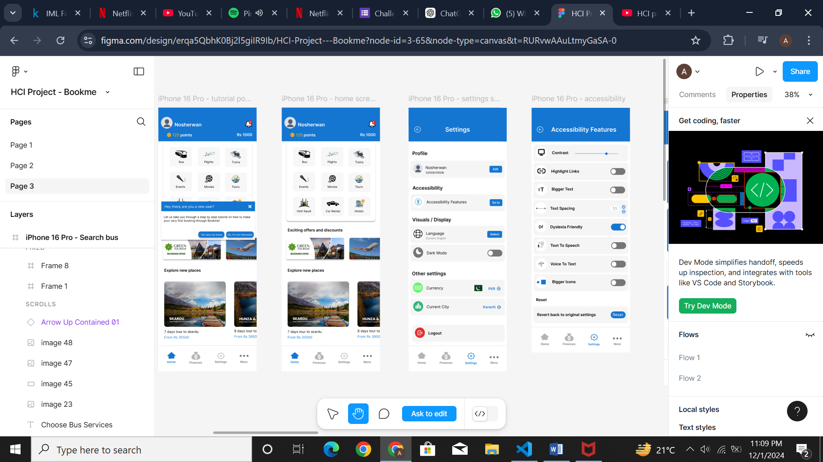

Before (More options):

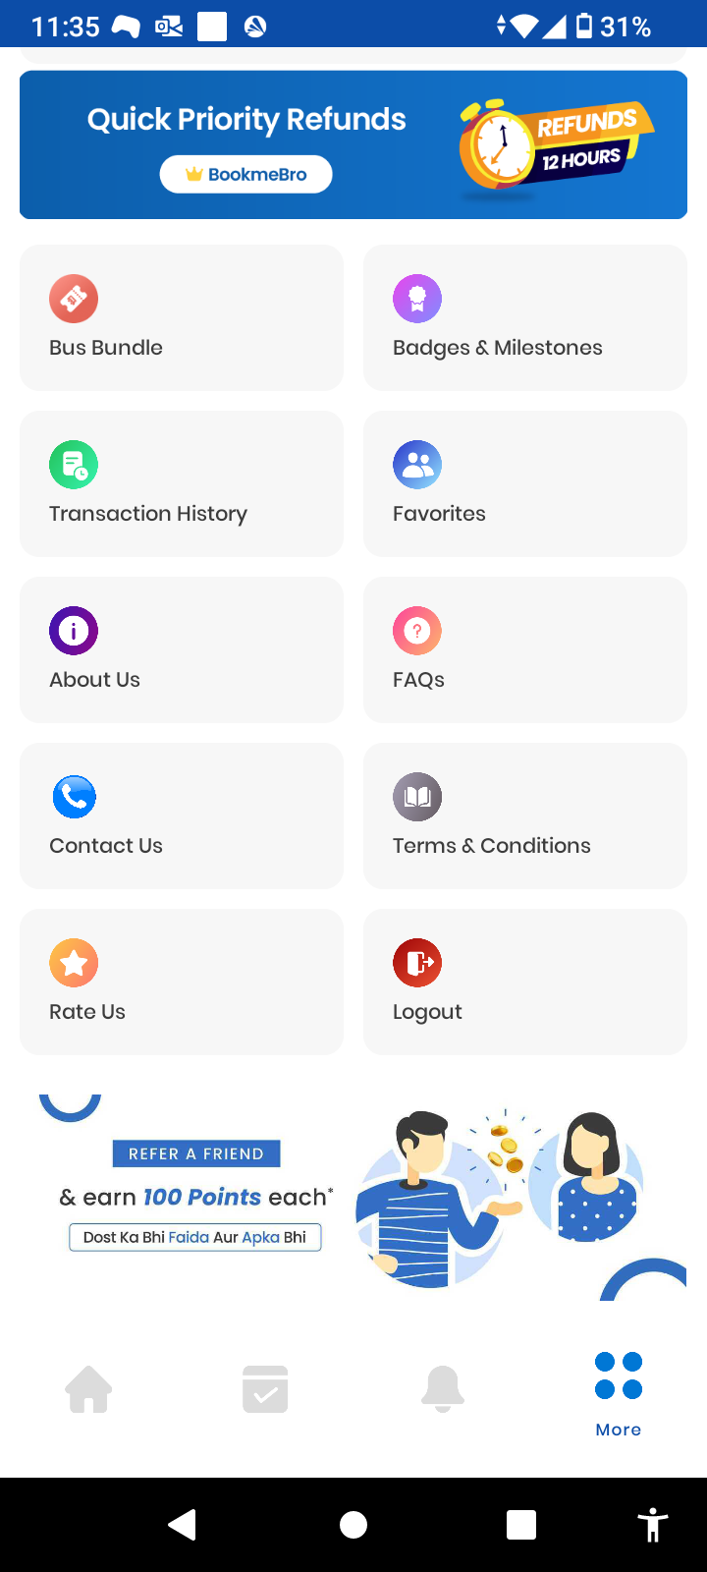

Before more options were in the same screen as settings.

After (More options):

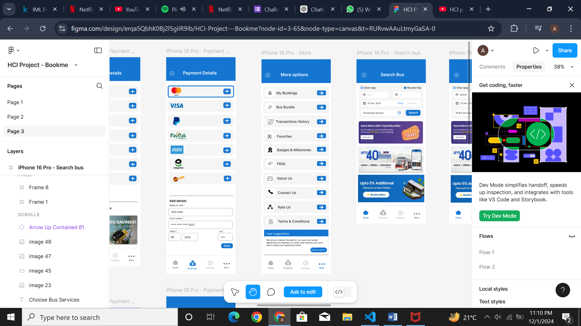

3. Accessibility Features

* Screen: Accessibility settings under the "Settings" tab.
* Enhancements:
  + Options to adjust contrast, text size, and spacing.
  + Dyslexia-friendly mode and text-to-speech/voice-to-text features.
  + Larger icons for visually impaired users.
  + A reset button to revert to default settings for flexibility.

*HCI Principle Applied:* **Accessibility** (customizable options for all user needs) and **user control and freedom** (reset button).

Before: There was no accessibility screen.

After:

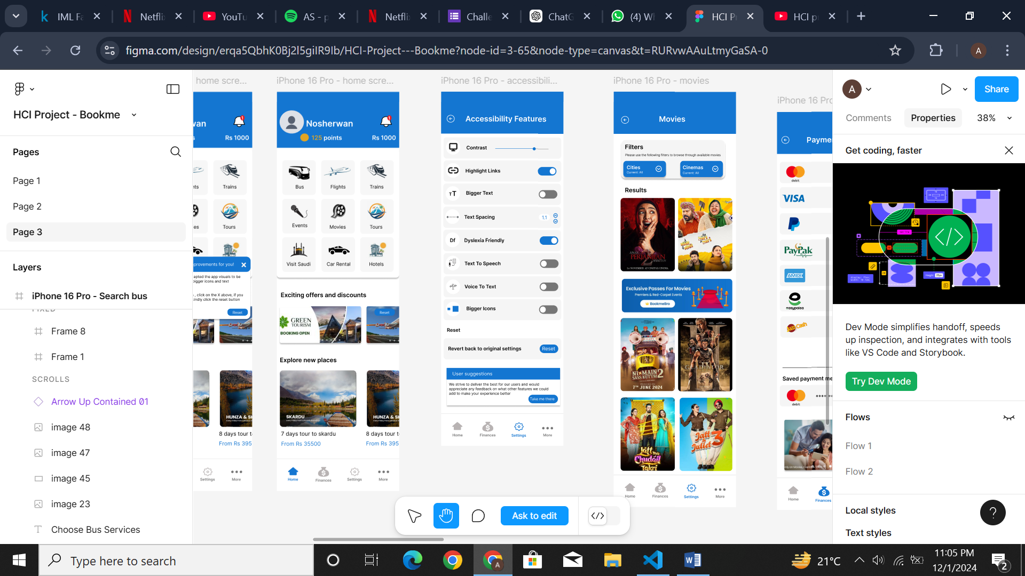

4. Financial Management

* Screen: Finances section.
* Enhancements:
  + Easy navigation for adding/redeeming funds and managing payment methods.
  + Add payments option placed to save the preferences of the users for the mode of payments.
  + Integration with local and international payment systems (e.g., PayPak, EasyPaisa, PayPal, etc.) instead of just the HBL option that the current Bookme supports.

*HCI Principle Applied:* **Flexibility** and **efficiency of use** (integration with diverse payment systems).

Before:

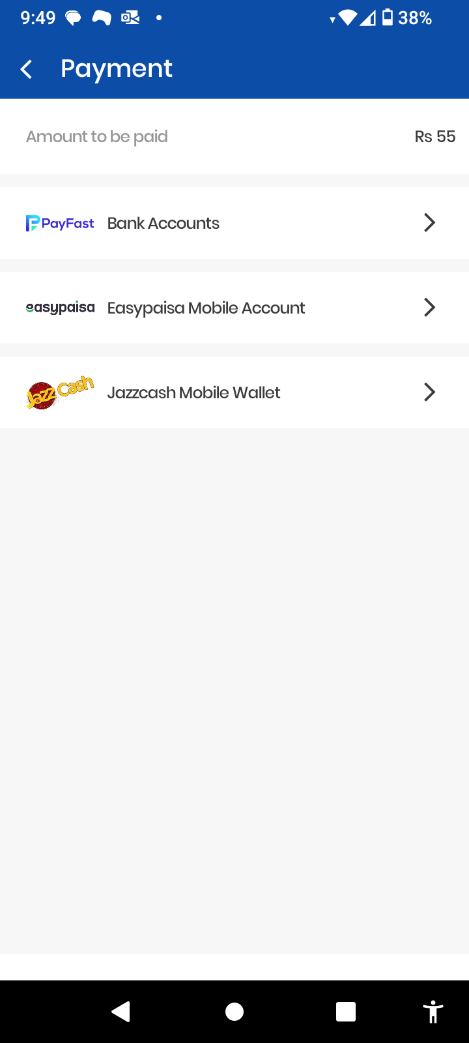

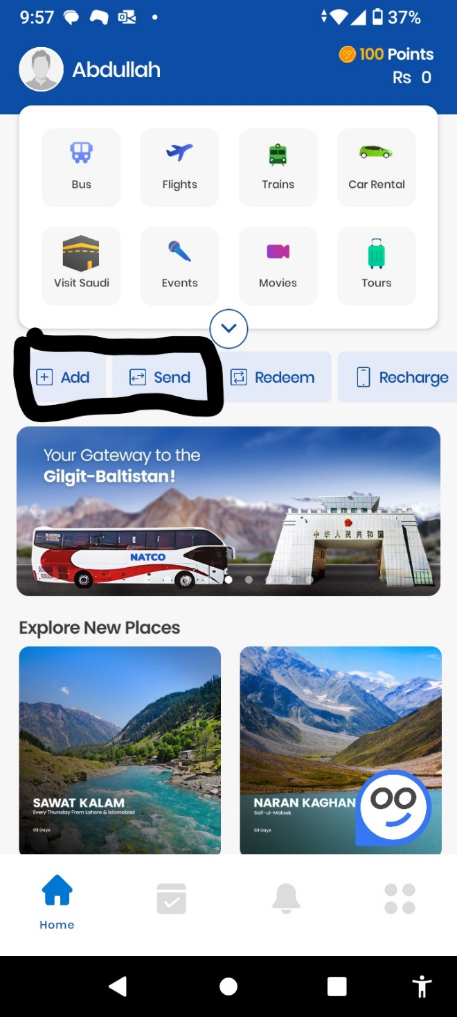

Use of vague terms like send and add. Fewer payment options before and no saving of info by the way you pay.

After:

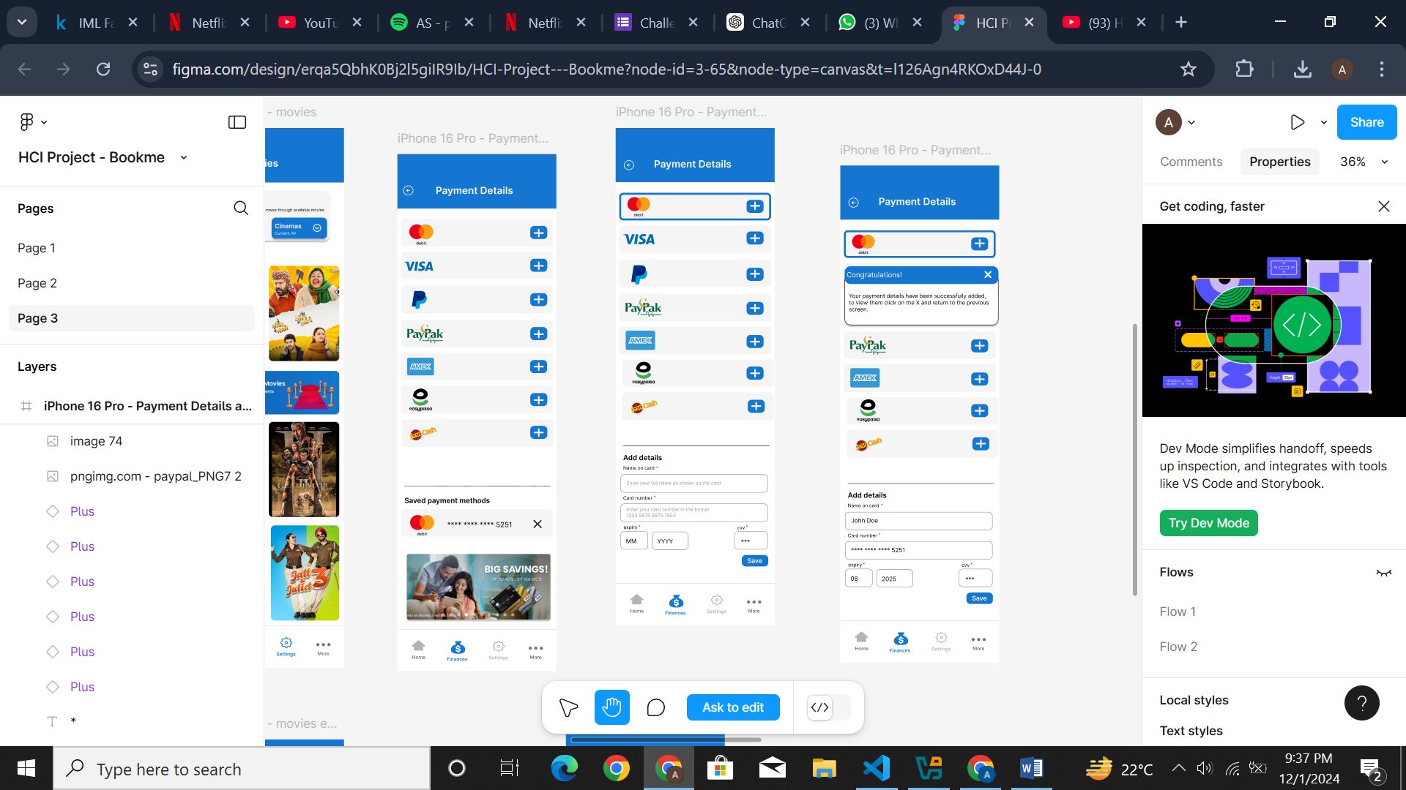

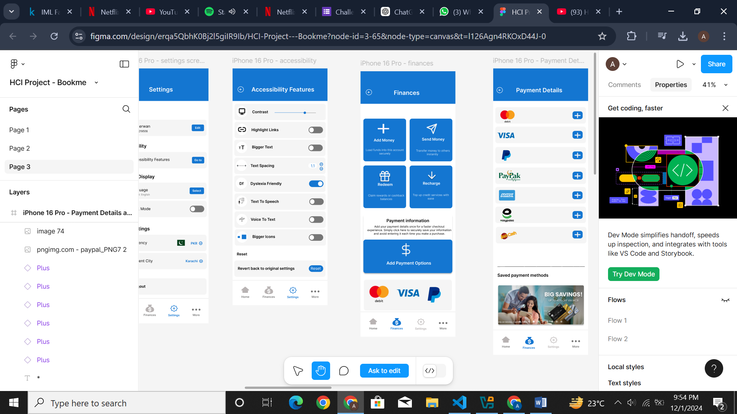

5. Enhanced Booking Experience:

* Screen: Bus Booking
  + Enhancements:
    - Yellow search button converted to a blue box for **internal consistency**.
    - Vague ‘female’ tag replaced by a more descriptive label ‘Female passenger travelling’ to avoid confusion about female-only buses.
    - Blue box used for seat selection instead of a yellow box to follow convention.
    - Breadcrumbs/progress bar maintained to show users their status in the booking process.
    - Required fields marked with an asterisk, and unnecessary nicknames removed while entering passenger details.
    - Accepted format for email and CNIC fields shown as placeholders for error prevention.
    - A ticket receipt screen added at the end of the booking process to show confirmation of payment.
    - Download and share receipt options added to further facilitate users.
* Screen: Movie Selection
  + Enhancements:
    - Filter options added under the ‘filter’ label, and options follow the blue box convention.
    - While viewing the movie detail page, if a user encounters any error, an appropriate error message is displayed with an option to move back to the previous screen instead of the app freezing.

*HCI Principle Applied:* **Feedback and error prevention** (error messages and descriptive labels) and **visibility of system status** (progress bar and ticket receipt).

Before (Movie Screen):

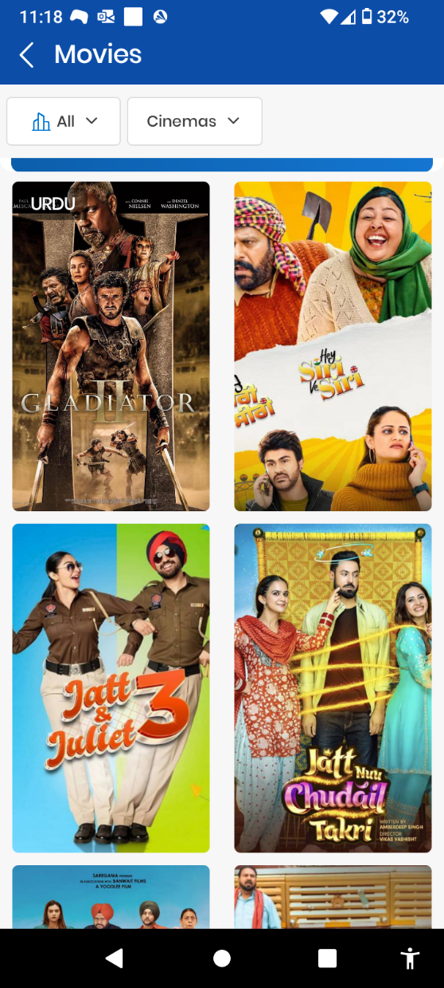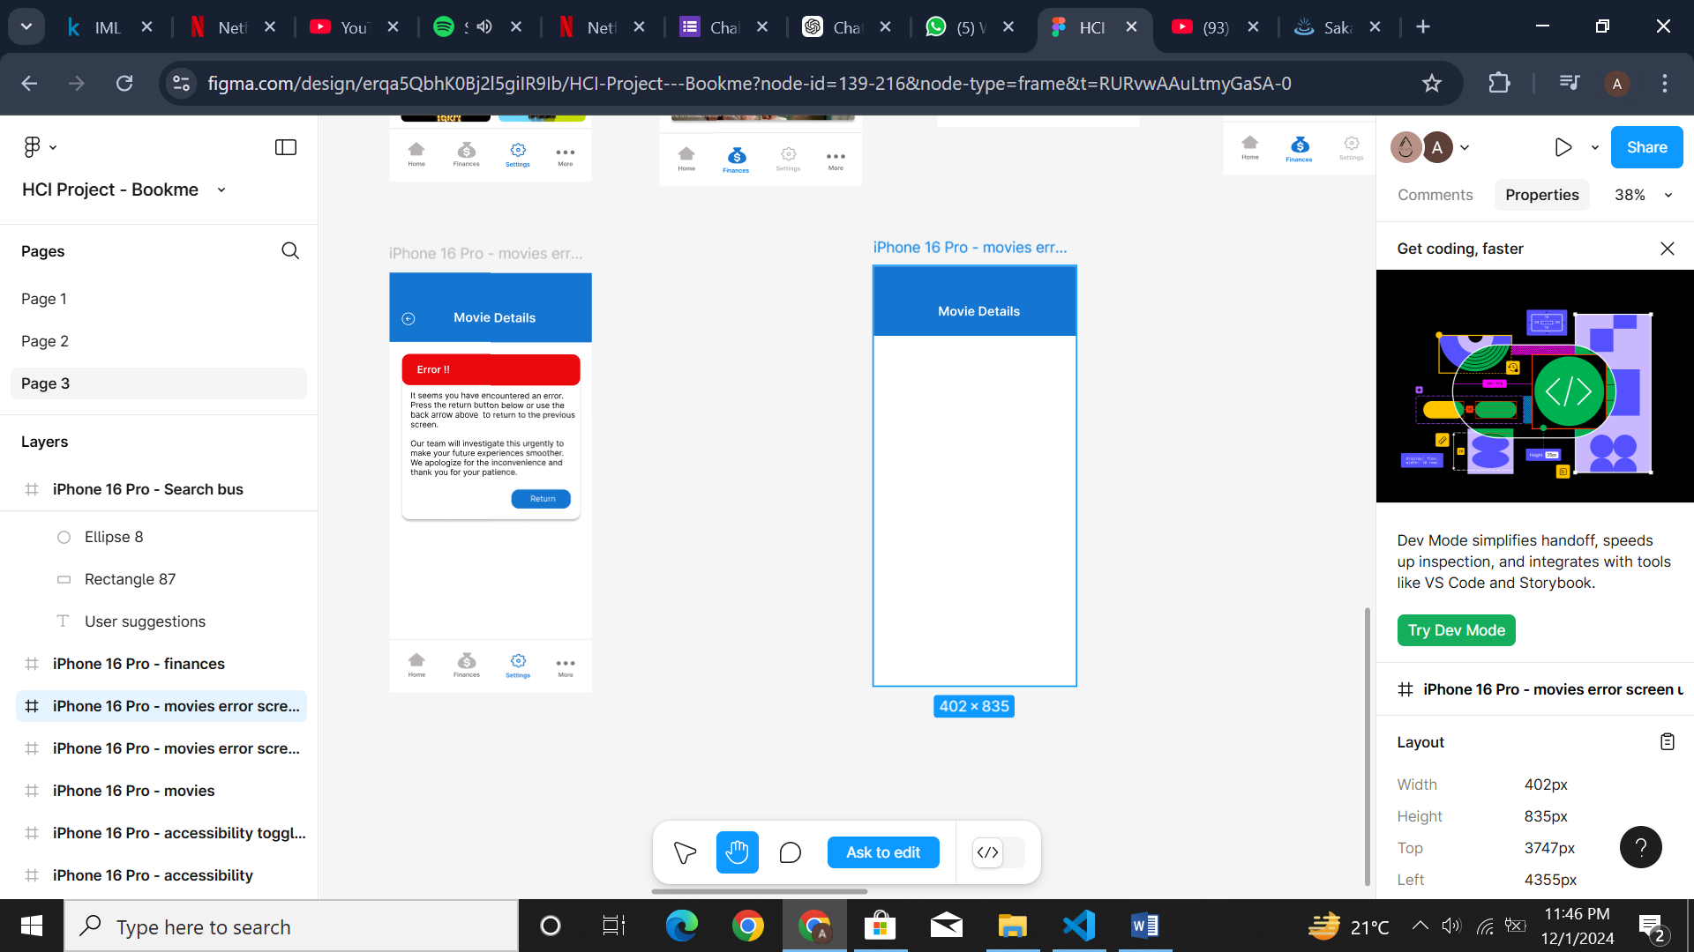

After (Movie Screen):

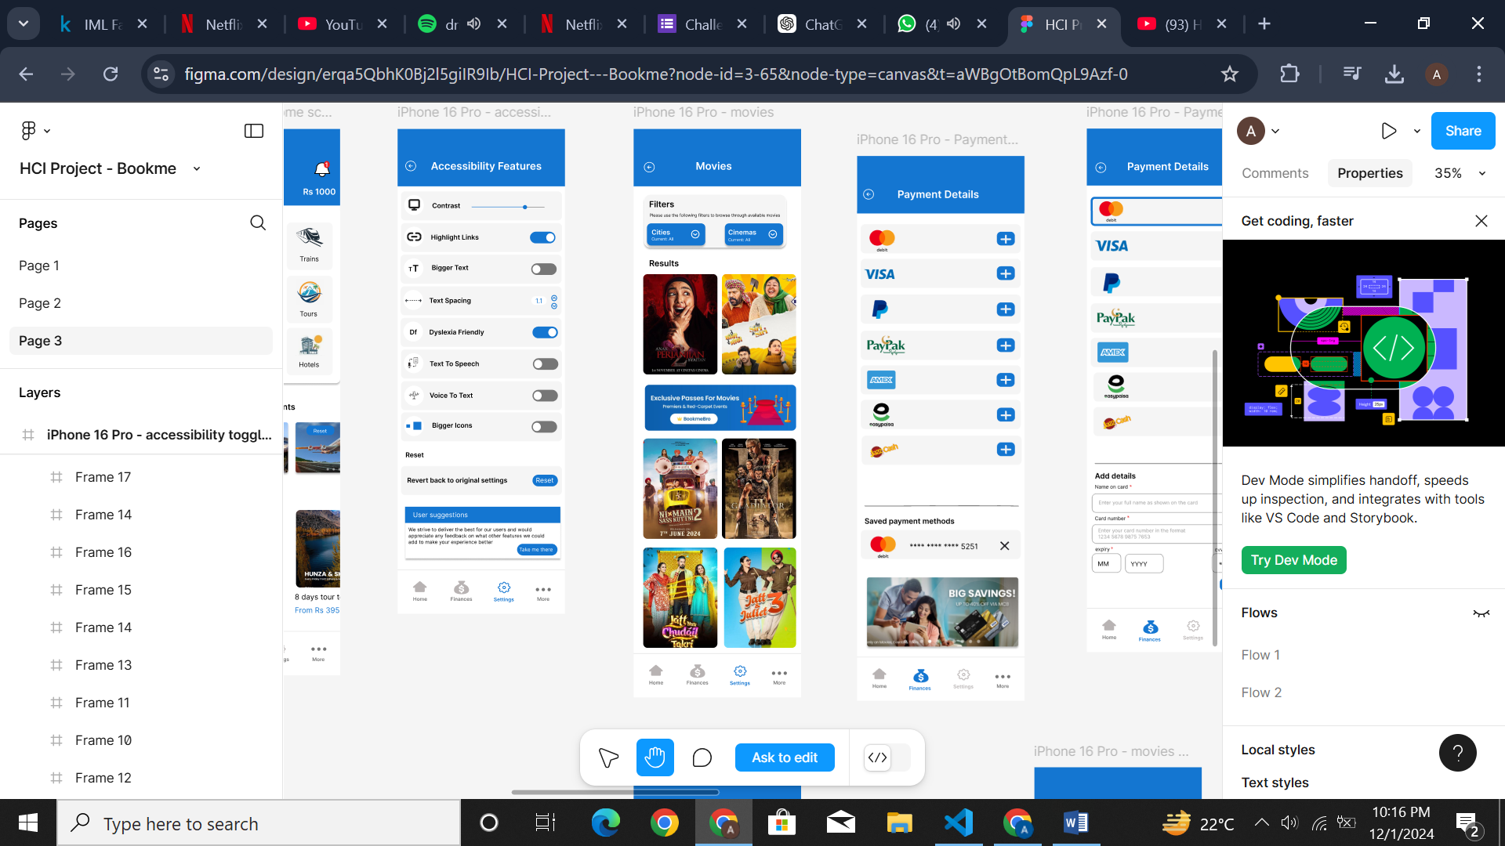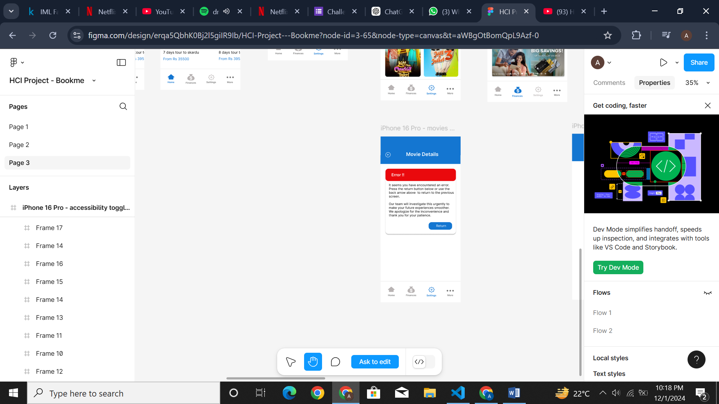

Before (Bus booking):

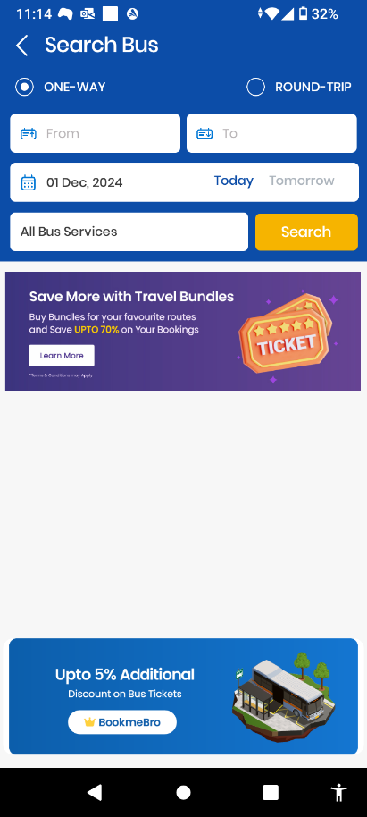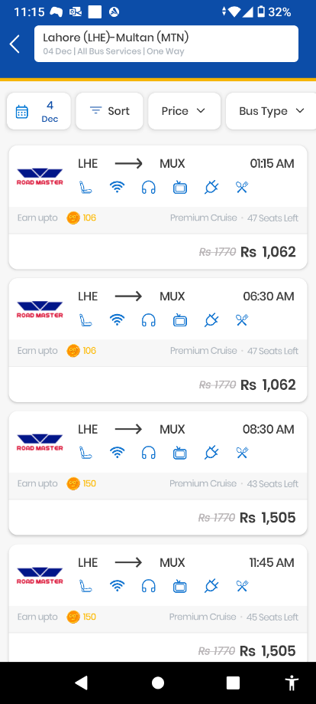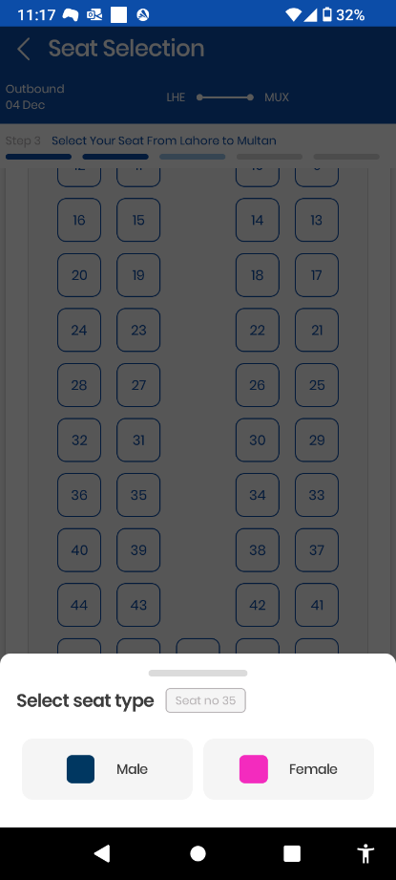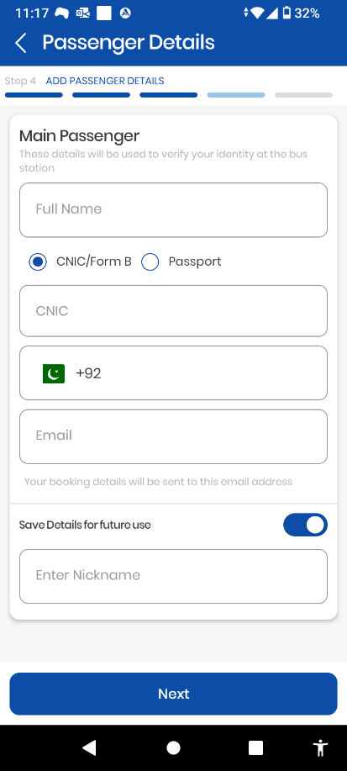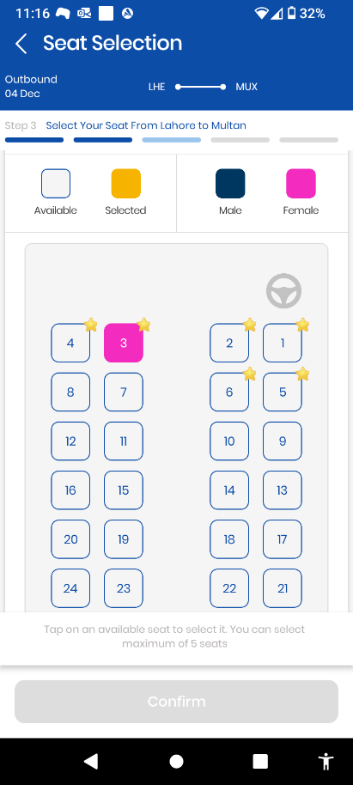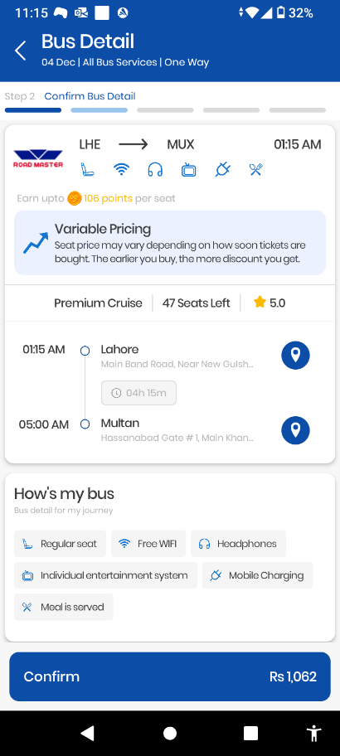

After (Bus booking):

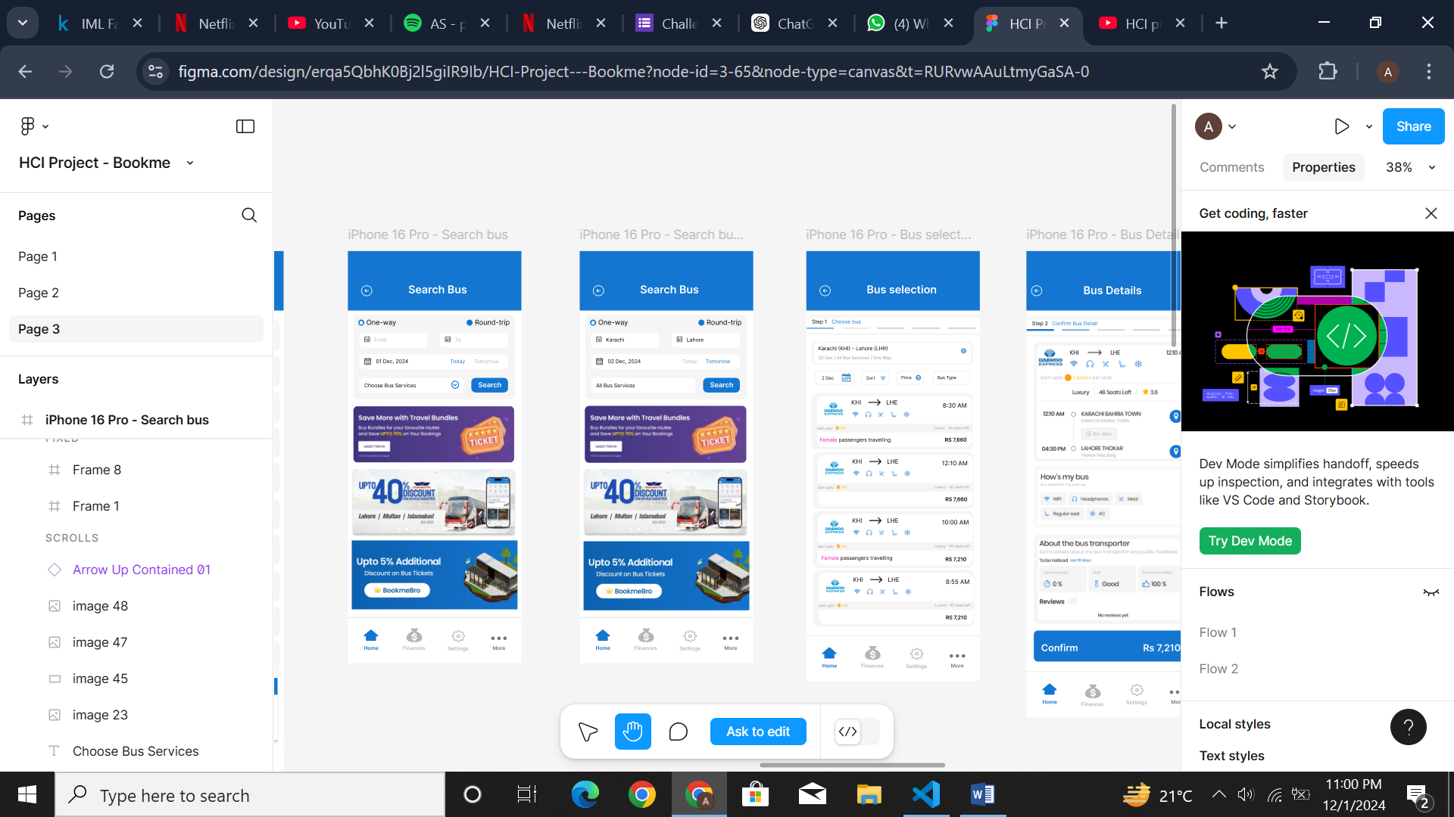

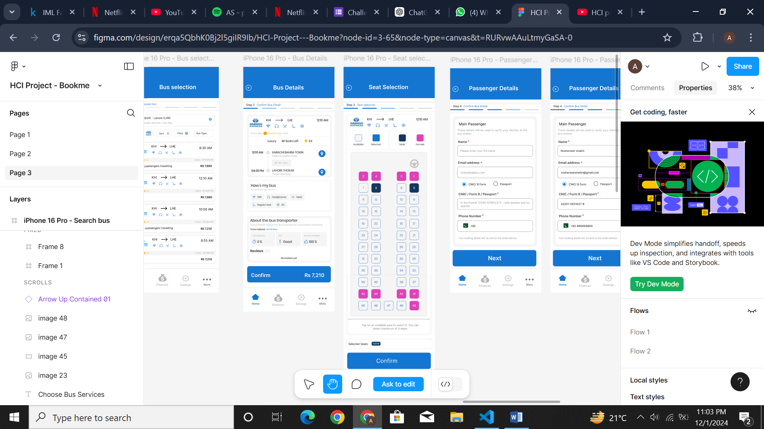

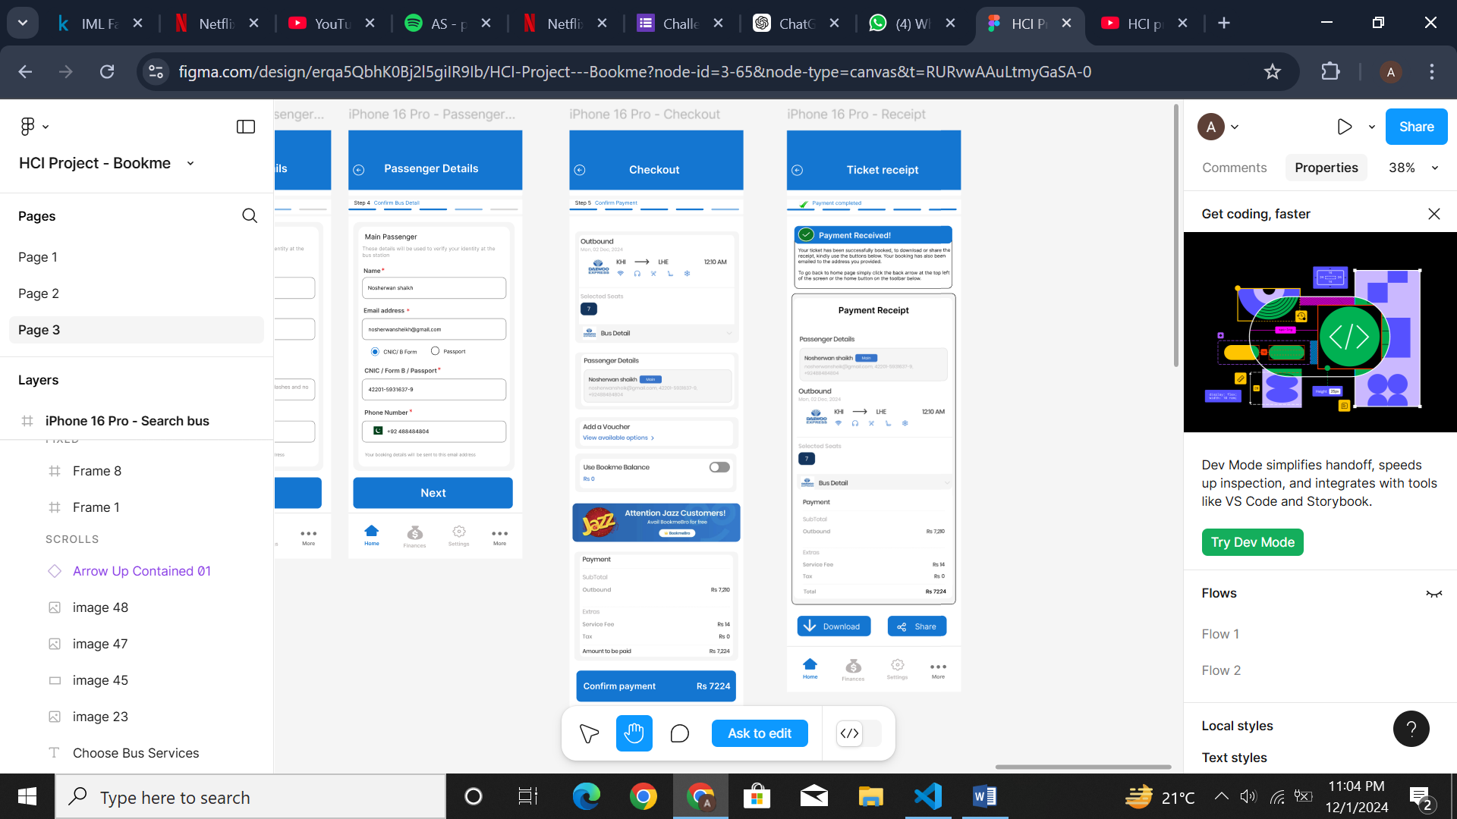

Design Rationale

The redesign focuses on the following:

1. Senior Citizens:
   * Larger fonts, simplified navigation, and voice interaction features.
2. Disabled Users:
   * Accessibility settings (e.g., text-to-speech, voice-to-text, and contrast adjustments).
3. Illiterate Users:
   * Visual cues, minimal text reliance, and language switch options. Icons are prioritized for functionality.
4. General Users:
   * Personalized content, easy payment options, and streamlined processes.

HCI Principle Applied: **User-centered design** ensures that features address the specific needs of diverse user groups, aligning with feedback from Phase 1.

**Evaluation Plan for Redesigned Bookme Application**

**Objective:**

To evaluate the usability and effectiveness of the redesigned Bookme application for different user groups: **new users, frequent users, older users, and disabled users**.

**Hypotheses:**

1. **New Users:** The redesigned interface will increase task completion rates and reduce time to complete onboarding tasks compared to the original design.
2. **Frequent Users:** The redesigned app will result in higher satisfaction scores and faster task completion times compared to the previous version.
3. **Older Users:** The personalized and accessible design will improve usability, measured by fewer errors and higher satisfaction scores.
4. **Disabled Users:** Accessibility features will enhance task completion rates and reduce the cognitive load during interactions.

**Evaluation Design:**

**Study Type:**

* **Mixed Design** (Combination of Within-Group and Between-Group Comparisons).

**Variables:**

1. **Independent Variables:**
   * User Group (New, Frequent, Older, Disabled).
   * App Version (Redesigned vs. Original).
2. **Dependent Variables:**
   * **Task Completion Rate:** Percentage of tasks successfully completed.
   * **Time on Task:** Time taken to complete each task.
   * **Error Rate:** Number of errors encountered during task execution.
   * **User Satisfaction:** Measured using a standardized questionnaire (e.g., SUS - System Usability Scale).
   * **Cognitive Load:** Measured using the NASA-TLX scale.

**Participants:**

* **New Users:** 10 participants with no prior experience using the app.
* **Frequent Users:** 10 participants who use the app at least 5 times a month.
* **Older Users:** 10 participants aged 60+.
* **Disabled Users:** 10 participants with visual, auditory, or motor impairments.

**Evaluation Scenarios and Tasks:**

**Common Tasks for All Groups:**

1. **Sign-Up or Log-In:**
   * Create an account or log in to the system.
2. **Booking:**
   * Book a bus ticket with specific seat preferences.
3. **Payment Management:**
   * Add and save a payment method for future use.
4. **Settings:**
   * Change the language and adjust accessibility settings.

**Within-Group Design:**

* **Procedure:**
  + Each participant will use both the original and redesigned versions of the app.
  + **Task Order:** Counterbalanced to avoid order effects.
  + Metrics such as task completion time, error rate, and user satisfaction will be compared within each group for the two app versions.

**Between-Group Design:**

* **Procedure:**
  + Each group (new, frequent, older, disabled users) will use the redesigned app.
  + Metrics such as task completion rates and satisfaction scores will be compared across groups to assess the app’s performance for diverse user demographics.

**Data Collection Methods:**

1. **Observation:**
   * Record participant interactions to identify usability issues.
2. **Think-Aloud Protocol:**
   * Participants verbalize their thoughts while completing tasks.
3. **Surveys and Questionnaires:**
   * Post-task and post-test surveys to measure satisfaction and perceived usability.
4. **System Logs:**
   * Automatically record task completion time and errors.

**Expected Outcomes:**

* **New Users:** Improved task completion rates and reduced cognitive load due to clear guidance and tutorials.
* **Frequent Users:** Higher efficiency and satisfaction due to consistency and streamlined navigation.
* **Older Users:** Enhanced usability through larger icons, personalized screens, and voice interaction.
* **Disabled Users:** Increased accessibility and reduced barriers through adjustable settings and assistive features.